# Intro

* Start with final product
* Sum up what’s happening at a high level – don’t introduce anything they don’t already know:
  + [Show final demo with individual terms spinning]
  + This complex shape is made out of a bunch of spinning vectors, like these
  + When we add the vectors together, tip-to-tail, it draws out some shape over time.
  + By tweaking the initial *size* and *angle* of each vector, we can make it draw anything we want
* **Each component, an arrow spinning at constant speed, is super simple. But these simple pieces added together can make something that’s super complex.**

# Series

* The idea of building complex things out of simple pieces in math is called a **series**.

## Constant Series

* [Have students think of real-world series]
* Real world examples:
  + Paying with cash (adding discrete pieces to get close to the final answer);
    - [Have students create a final dollar value from different cash values]
  + walking a mile by walking half as far as you have left an taking a rest
  + [Illustrate mile walking problem on white board]
* Here’s a series for the number pi
  + [show pi series demonstration]
* **For the walking and pi examples, Finite sums will always by approximations**. No matter how many terms we add, we won’t get exactly the right answer, but we can get as close as we want by adding more and more terms.
  + Introduce number of terms

## Series of Functions

* We can also use series to describe things that change over time
* With functions, we’re doing the same thing but with many different values at the same time.
  + [show 3Blue1Brown Demo]

### Sound as a Series

* Now what if I told you that sound is a series?
* Sound is a series of different-speed waves that move from the source to your ear
  + [How sound works animation]
* The speed of the wave determines the “pitch” of the sound – how high the note sounds to our ears.
  + [Sound generation while manipulating the frequency of the sound]
* Now things get interesting when we start adding these different sound waves together
  + [Manipulate with different sounds and sinusoids overlapping to form a chord]
  + Optional
    - [show Piano chord audio in time domain]
    - [show how a bunch of waves at different frequencies add up to make the sound]
* **The waves are the building blocks – or basis – for making the more complex sound**

# Shazam Example (If time)

<http://coding-geek.com/how-shazam-works/>

* When you Shazam a song – it takes a “fingerprint” of the audio and compares it to fingerprints of songs in their database.
* The “fingerprinting” algorithm first breaks the audio into frequencies, creating a spectrogram.
* It then keeps only the loudest notes from the spectrogram, with means any background noise when you’re Shazaming a song doesn’t matter.
* 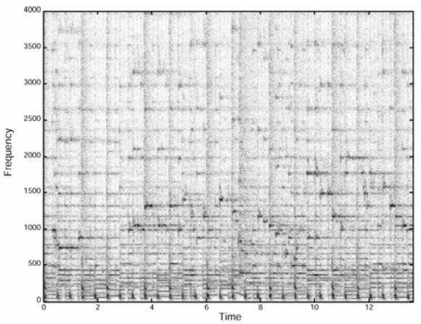->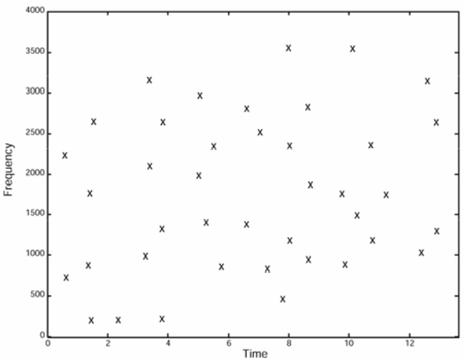
* They then use a clever search algorithm to match the fingerprints that you record to the fingerprints in their database.

# Complex Exponentials = Spinning Arrows

* [Do they know what an exponential is? What a vector is? Write a sample exponential?]
* Just like different sound waves can add together to create any sound, spinning vectors can add together to draw any continuous line.
  + Sound is 1-Dimensional (pressure vs time), while the spinning vectors are 2D (x,y vs time).
* In Math, we use something called a “Complex Exponential to represent our spinning vectors.
  + To draw a vector $\overline{v}$ that is one unit long at an angle $θ$ to the horizontal line:
 $\vec{v}=e^{i∙θ}$

   - [Plot $e^{iθ}$ for different angles]
  + To make the vector spin, replace $θ$ with $ωt$
    - $\vec{v}\left(t\right)= e^{iωt}$, $ω=2πn=angular velocity in\frac{rad}{s};i=\sqrt{-1};t=time$
    - [Plot $e^{iωt}$ for different speeds]
  + If they ask why f(t) makes a circle, point them to Euler’s Formula: $e^{iθ}=\cos\left(θ\right)+i∙sin⁡(θ)$, which comes from the Taylor *series* expansion of $e$.

# Control Knobs

* So far, our basic building blocks are unit vectors that spin at different speeds. How do we combine them to make them draw what we want?
* For each spinner, we control its *length* and *starting angle* by multiplying them with a coefficient: $c_{n}=r*e^{iθ}$
  + [Demonstrate how multiplying the spinners with different coefficients work]
* We can add these spinners up to make a series, just like we did with numbers and waves
  + [Add random spinners to make cool spirographs]
* So if we have a goal drawing, how do we know where to turn our control knobs length and angle to make it do what we want?
  + [Try randomly tweaking the coefficients, show its really hard to do by hand]
* Again, math has the answer:
$c_{n}=\frac{1}{L}\int_{-L/2}^{L/2}{f\left(x\right)e^{-2πint}dt}$

* It looks super complicated, but all this formula says is that we set our control coefficient for each spinner to the *average* of our drawing times the same spinner in the opposite direction.
* We then get a $c_{n}$ for each spinner, multiply the spinner by its $c_{n}$, and add all the spinners together!

# Final Demo

* Try to show each step of the process here and let them experiment with it.

# Conclusion

* We can approximate almost anything if we have enough terms
* The beautiful thing is that we can take simple ideas, like spinning circles, and combine them to make things that are complex and beautiful.
* Really, this is how all of science and technology works
  + Our knowledge about how the world works is built out of a bunch of simple discoveries that have added up to the understanding we have today.
  + Our cars started with the discovery of the wheel…
  + Tie it back to how they can contribute to STEM by following their curiosity and contributing small things.